Data Analytics (DA)
Module -4
Python Assignment 2- Data Structures - List, Dictionary, Set & Conditional Statements
Problem Statement:
As a Python learner, this assignment focuses on working with core data structures such as lists,
dictionaries, and sets, along with implementing conditional statements.

The objective is to develop a strong understanding of:
● List creation, modification, and access operations
● Dictionary creation and manipulation using key-value pairs
● Set properties and operations like uniqueness, union, and intersection
● Decision-making using conditional statements (if, elif, else)
You are required to write Python programs that demonstrate these concepts and display outputs as per the given tasks.

Tasks:
List (Creation, Modification, and Access):
1. List Creation:
a. Create a list named age_list with five integer elements. For eg., [24, 25, 27, 28 ,29]
b. Create a list named name_list with five string elements.
OUTPUT:
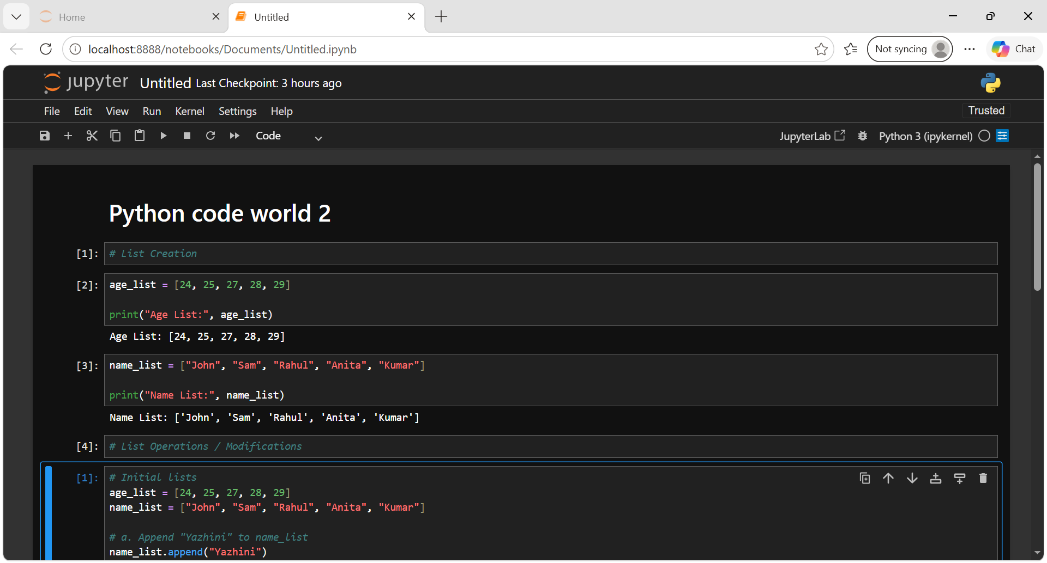

2. List Operations / Modifications:
a. Append the string "Yazhini" to name_list.
b. Insert the element 26 at index 2 in age_list.
c. Remove the string "Yazhini" from name_list.
d. Pop the last element from age_list.
e. Extend the age_list with additional ages [31,30,32].
f. Sort age_list in descending order.
g. Find the max age, min age, and sum of all ages from age_list.
OUTPUT:
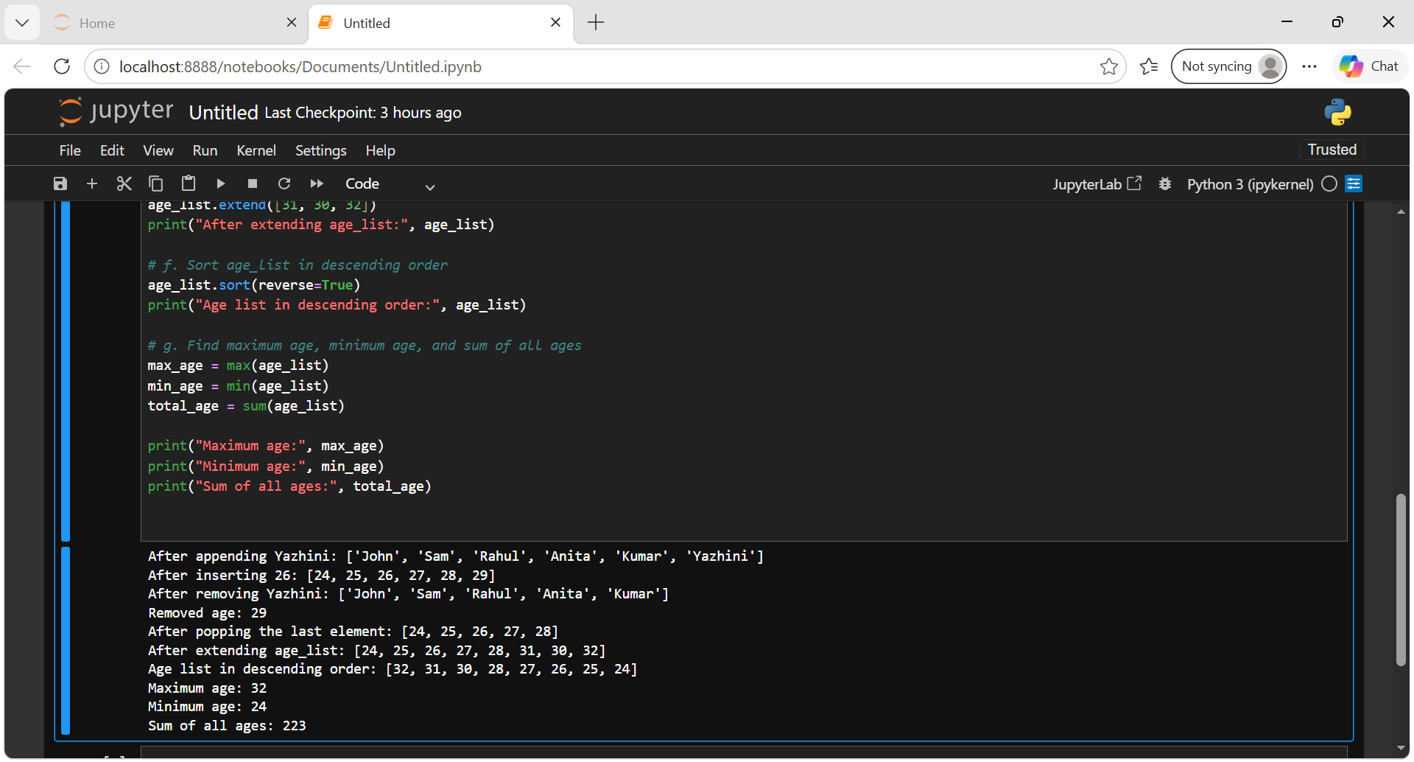

3. Accessing List Elements:
a. Print the first element of name_list.
b. Print the last element of name_list.
c. Print the elements from index 2 to index 4 in name_list.
d. Print the elements of name_list in reverse order.
OUTPUT:
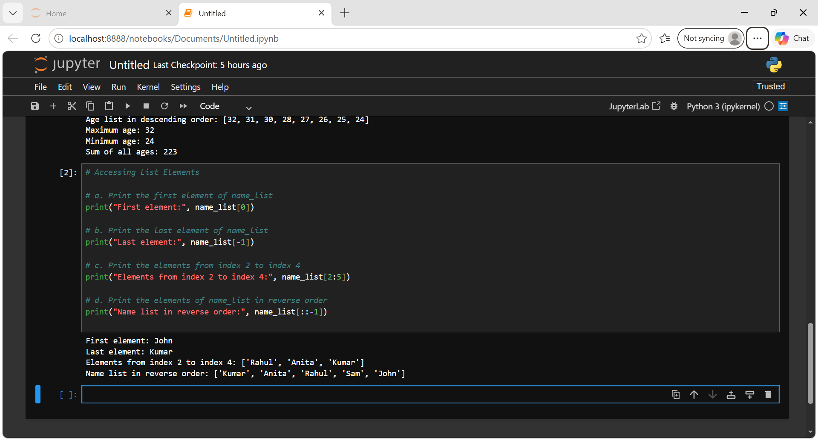

Dictionary (Creation, Modification and Access):
a. Create a dictionary named student_marks that maps the names of five students to
their marks (use a scale of 0 to 100).
b. Access and print the mark of a specific student of your choice.
c. Add a new student, "Janani," with a mark of 80 to the student_marks dictionary.
d. Update the mark of any one older student to 82.
e. Use the keys(), values(), and items() methods to print all keys, values, and key-value pairs in the student_marks dictionary.
OUTPUT:
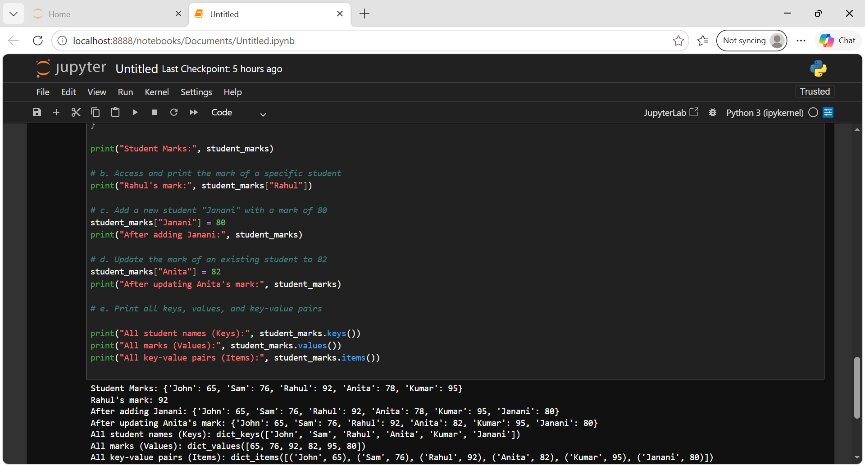

Sets (Operations):
a. Create a set called my_set with the following values: ['a','e','i','o','u','a','a','i']
Analyze the output and explain the same.
OUTPUT:
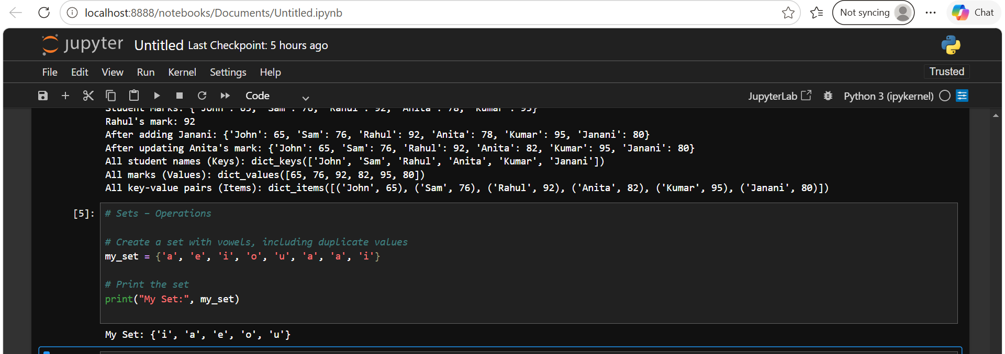

Explanation:
- A set in Python stores unique elements.
- Duplicate values are automatically removed.
- In the given values, 'a' appears three times and 'i' appears twice.
- Therefore, the duplicates are removed, and only one occurrence of each vowel remains.
- Sets are unordered, so the order in which the elements are displayed is not guaranteed.

b. Attempt to access my_set[4]. If the code throws an error, provide an explanation.
OUTPUT:
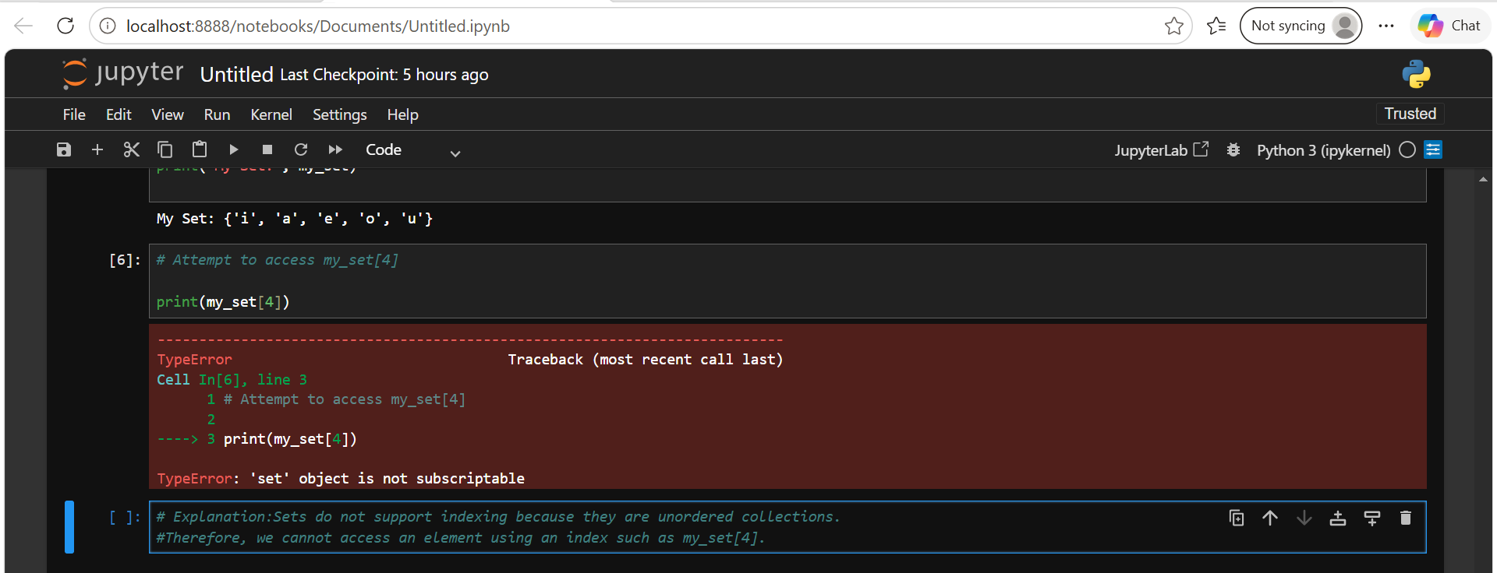
Explanation:
Sets do not support indexing because they are unordered collections. Therefore, we cannot access an element using an index such as my_set[4].
For example:
my_set[0] # Not allowed
my_set[4] # Not allowed

c. Create two sets:
set1 with values: {1, 3, 5, 7, 9}
set2 with values: {2, 3, 5, 8, 10}
OUTPUT:
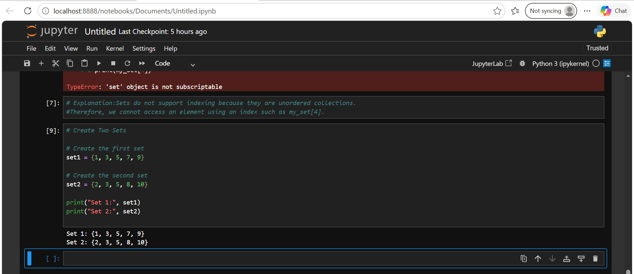

d. Compute and print the union and intersection of set1 and set2.
OUTPUT:
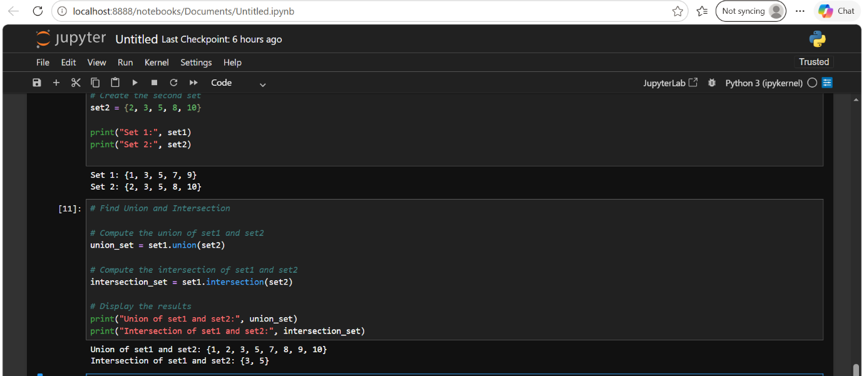
Operators & Conditional Statements : (IF, ELIF, ELSE)
Performance Category Program:
- Prompt the user for input. Score range should be from 0 to 10 (both inclusive).
OUTPUT:
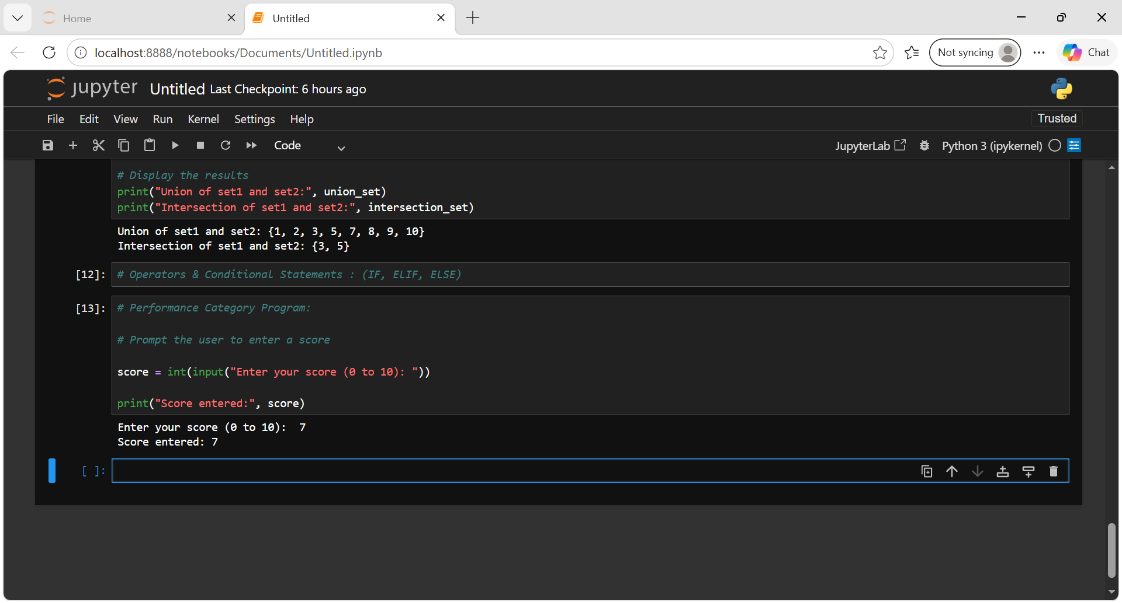
2. Find the performance category based on the input score using the following criteria:
a. Above Average: Score greater than 7
b. Average: Score between 4 and 7 (both inclusive)
c. Below Average: Score less than 4
3. Output: Print the Performance category
4. Additional Step: You can give a prompt of your choice to each category. For example, if the score is below average, “Need to improve your performance; consistent practice will lead to better results”.

OUTPUT:
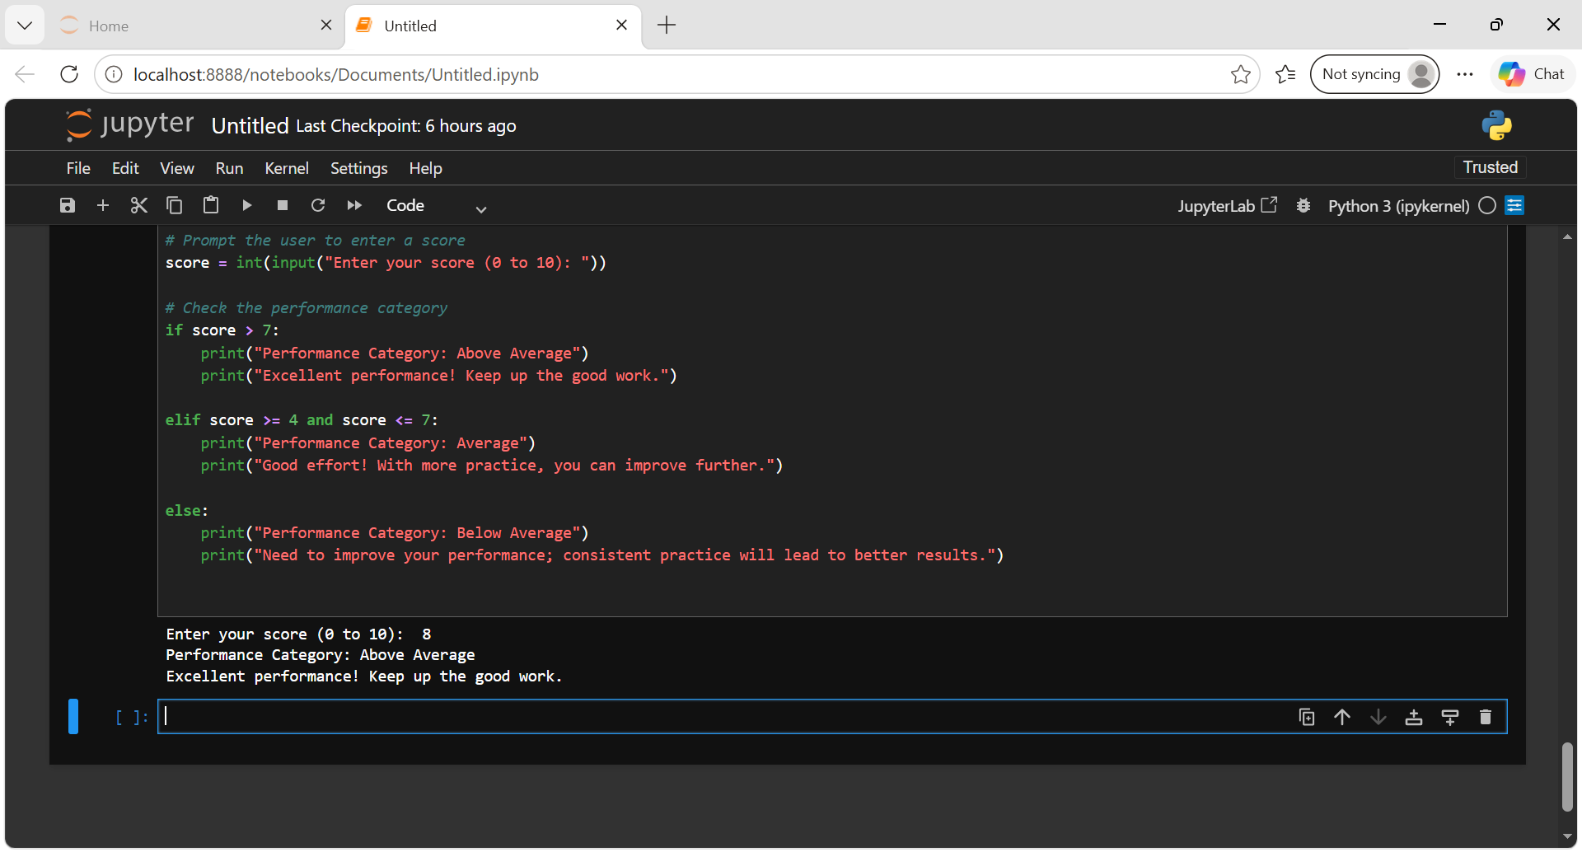

Conclusion
This assignment provided practical experience in working with important Python data structures and conditional statements. Through the exercises, I learned how to create, access, modify, and perform operations on lists, dictionaries, and sets.
The list exercises helped me understand operations such as adding, removing, inserting, sorting, and accessing elements. The dictionary exercises demonstrated how to store and manage information using key-value pairs, while the set exercises helped me understand uniqueness, union, and intersection operations.
The assignment also strengthened my understanding of conditional statements (if, elif, and else) by using them to categorize performance based on a given score. Overall, these exercises improved my Python programming fundamentals and provided a strong foundation for writing logical and efficient Python programs.

